1. Open IPython notebook called homework_3.ipynb (EDSR-PyTorch)
2. Press “Kernel” and “Restart & Run All” in your notebook

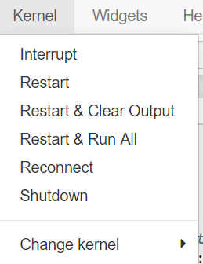

1. Using the pic paths.png relocate all this dirs from folder datasets to

"/home/ma-user/work/coding 3/datasets/high resolution images/dataset”

(just use the button “move” in ModelArts cloud).

1. Let’s repeat: Press “Kernel” and “Restart & Run All” in your notebook
2. After the 0 epoch will be trained and the evaluation starts we will get this error while saving the results: “*ValueError: x and y must have same first dimension, but have shapes (0,) and (1,)”*
3. Config.txt, error.txt and logs.txt are in the same folder with this “.word” file

I haven’t any solution of this problem